Sustainability Case Report Template
Part 1: Understand the Data and Problem
Task 1a: Before creating data visualizations, identify and discuss any data quality concerns related to the business travel and commuting datasets. You may highlight any issues you consider relevant; however, a useful reference is Table 7.6: Data Quality Indicators (page 76) in reporting_standard.pdf. Note: 1a and 1b are conceptual questions and do not require visualizations
Going through the Data, I noticed some fallacies that might impact the reliability of the data and the results coming from it. For the technological indicators, I noticed the topic of our analysis was not really relevant to that, but the data did provide information about the means of transportation used to travel or commute. For the temporal representative indicator, the data did not really explain that in detail as it only mentioned the year which I believe is not enough. I would want to explore the travel times and emissions per month or per day to perform. Geographical Representative indicator is also not apparent as there is no indication of where the employees traveled to during their trip.
Also, the data does not address fluctuations in travels during the seasons. If I had to guess, I don’t think the travels are the same across the year as some months get busier than others.

Task 1b: In Part 2 (see below), you will analyze the data for patterns and insights. For this task, outline a plan describing the patterns you intend to explore using your visualizations, and explain why you believe these patterns are important or useful to investigate.
I would like to explore the carbon emissions in each role in the company. Do some roles lead to more emissions than others or no. This will help us adopt a strategy that reduces travels for each team.
I will also explore emissions based on years to see if there is an improvement in the company’s strategy or not for emissions reduction.
Then I will explore emissions by every transportation mode to see if there is a mean of transportation that has a high emission rate and if the company can reduce their use or no.
I will investigate the distance and trips in Category 6 to see if the company is trying to reduce the number of trips and focusing more on remote work and teleconferencing.
I would also explore the means of transportation that were used for Category 7 to show what the company did to reduce the emissions.
Part 2: Make Sense of the Data
Task 2: Using Tableau, create 2 to 4 data visualizations that highlight general patterns in the Business Travel and Commuting Scope 3 emissions datasets. At this stage, focus on helping the reader understand how Category 6 (Business Travel) and Category 7 (Employee Commuting) emissions are distributed across the company. Note: You will evaluate the effectiveness of the two initiatives in Part 3, so do not focus on their impact here.
I have used Tableau to investigate the distribution of scope 3 emissions in Business and Commuting. I wanted to see which roles in the categories that were traveling more and resulting in higher emissions from 2016 to 2019.

For Commuting, I noticed that sales team had the higher contributions to emissions with Production and Executive coming second and third respectively. I noticed that there was a very significant difference between the production team and the rest of the teams, as shown by the visualization.

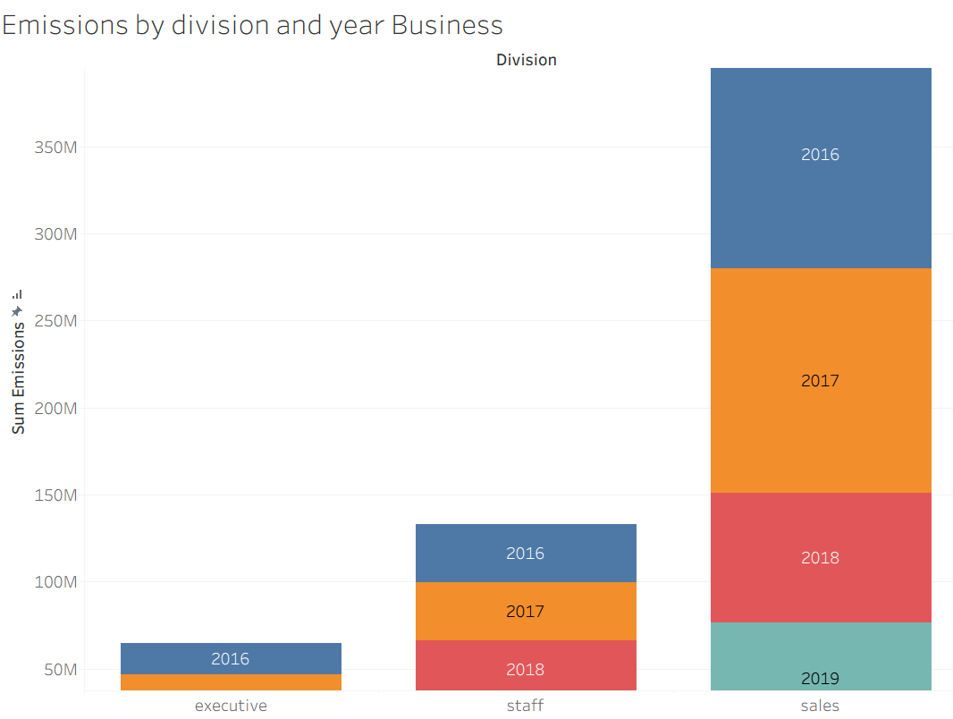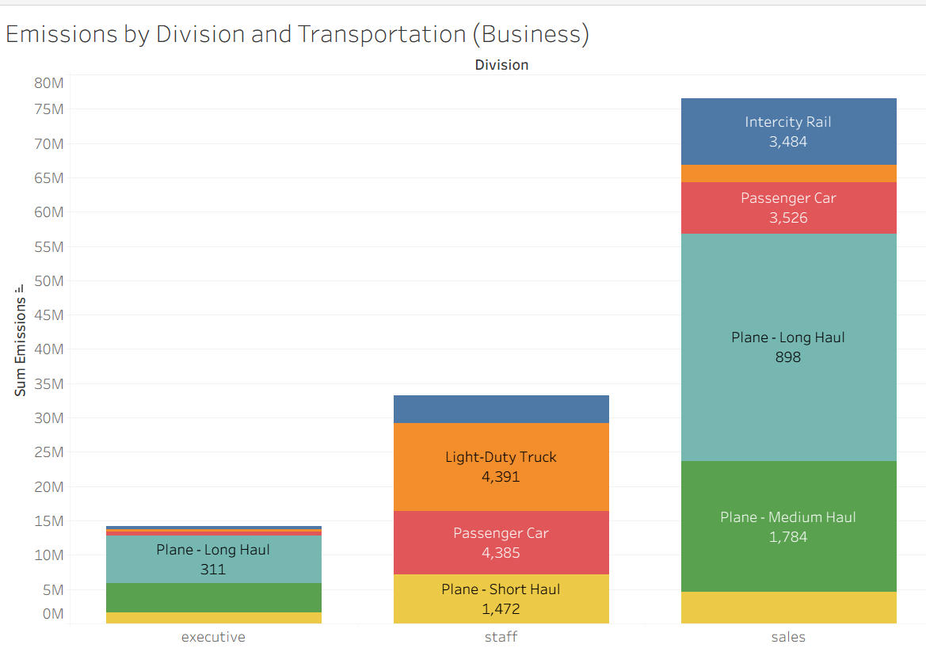

For the business category, I noticed there was high emission contribution by the Sales team in comparison with the Staff and Executive who came in second and third respectively. There is a large difference between the 3 divisions which should be further investigated to see if it due to the number of trips or to the means of travels used.
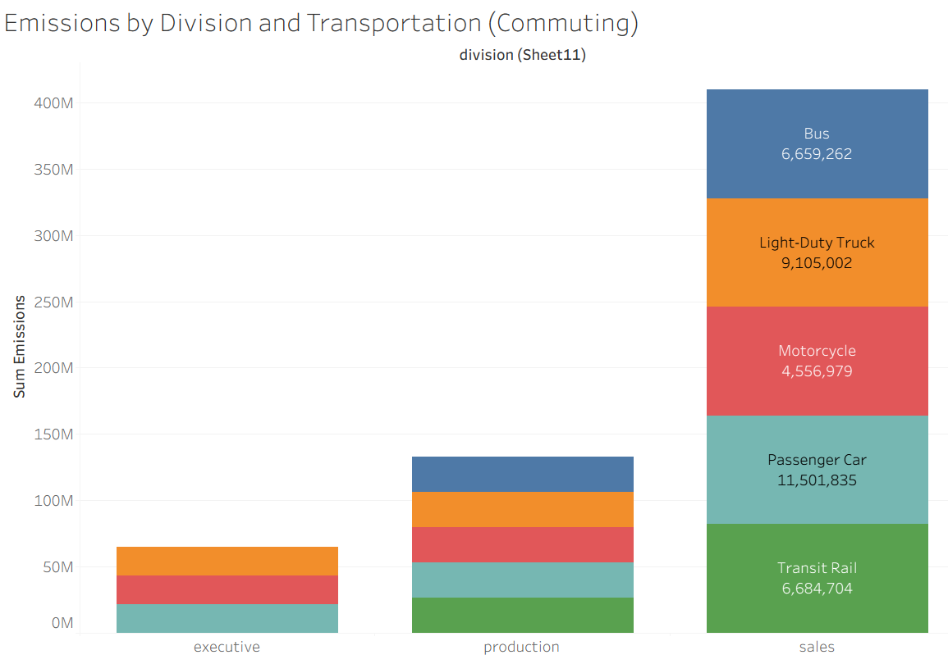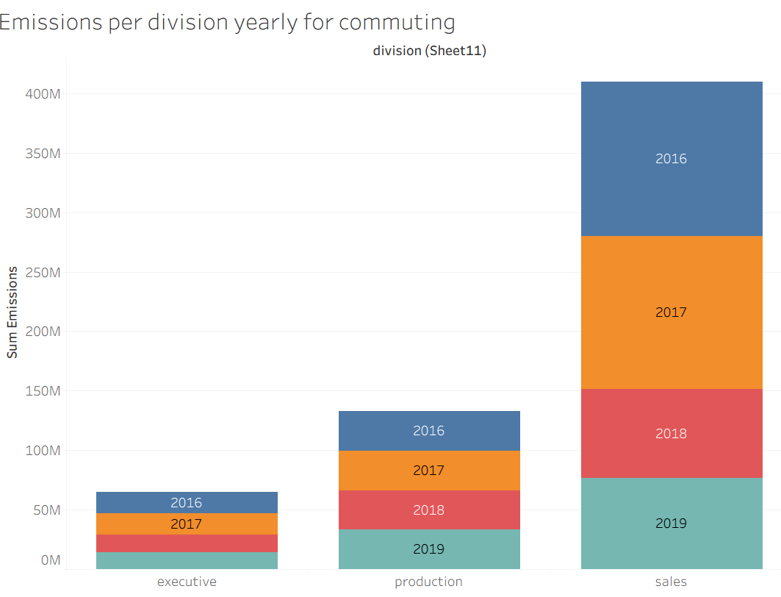

Part 3: Evaluate Company Initiatives
Task 3a: Evaluate the outcomes and effectiveness of the first company initiative, which aimed to reduce business travel (Category 6) emissions. Support your evaluation with 1 to 3 data visualizations created in Tableau.
I investigated the Business Category’s 3 emission types across 3 years, and have noticed that
that the 3 emissions have significantly decreased in 2018 and were relatively stagnant in 2019.
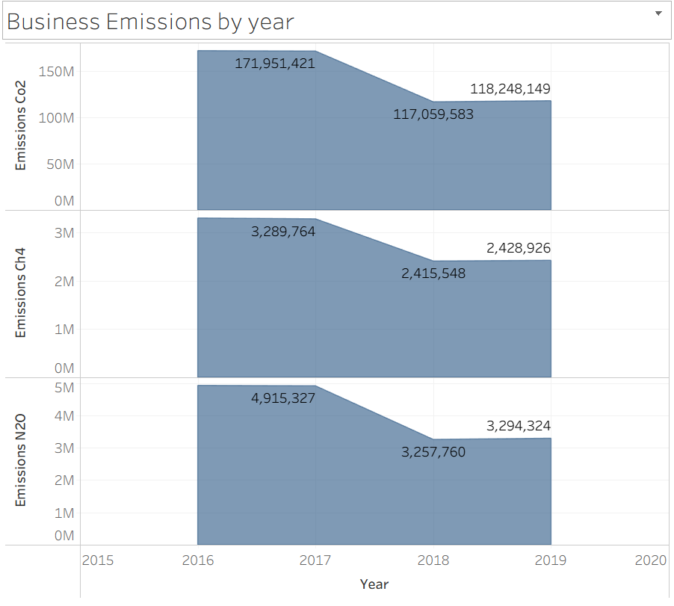
Investigating further, the company has significantly decreased the number of trips in the sales of the team from 2016 to 2017 and 2018.
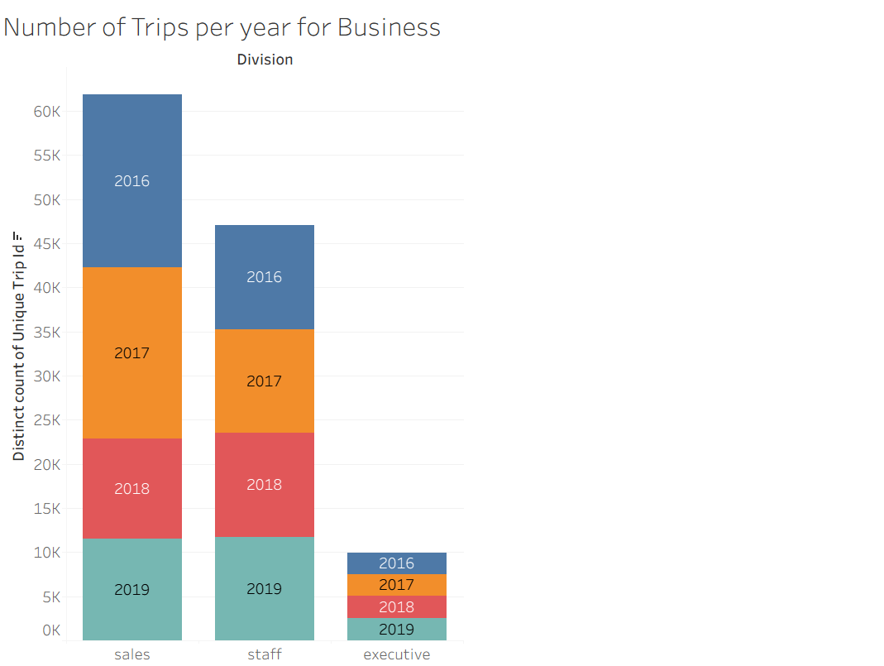
The company focused on decreasing the number of trips taken by Plane long hauls and plane medium hauls which are significant contributors to emissions as shown by the visualization below. Light duty truck trips were also reduced significantly. There was a decrease in the other categories as well, which means the company reduced traveling in general and resorted to virtual teleconferencing instead to cut down on emissions. The last graph shows a steep reduction in distance over the 3 years confirming the teleconferencing strategy implementation.
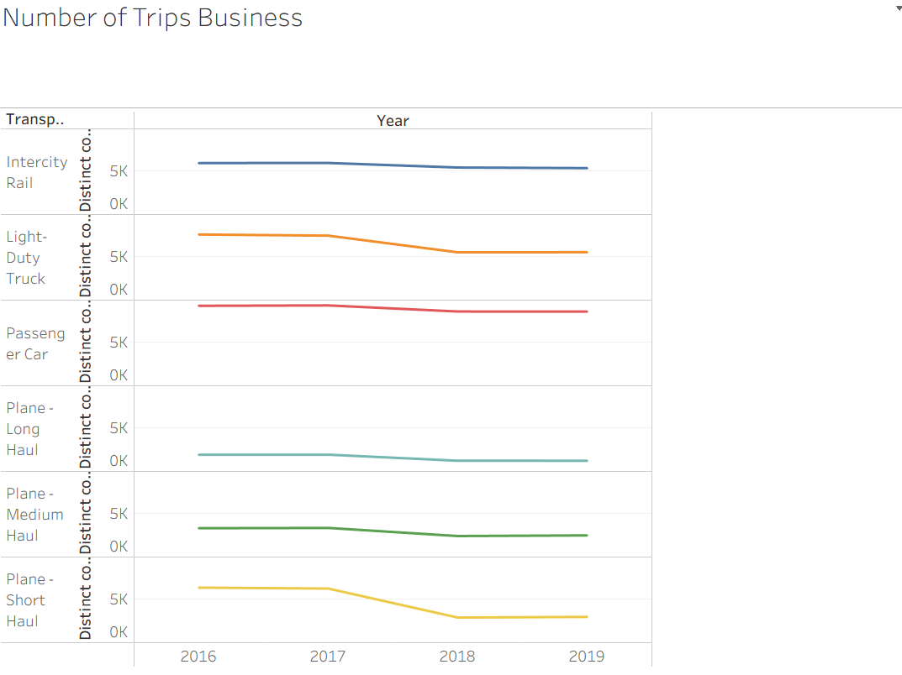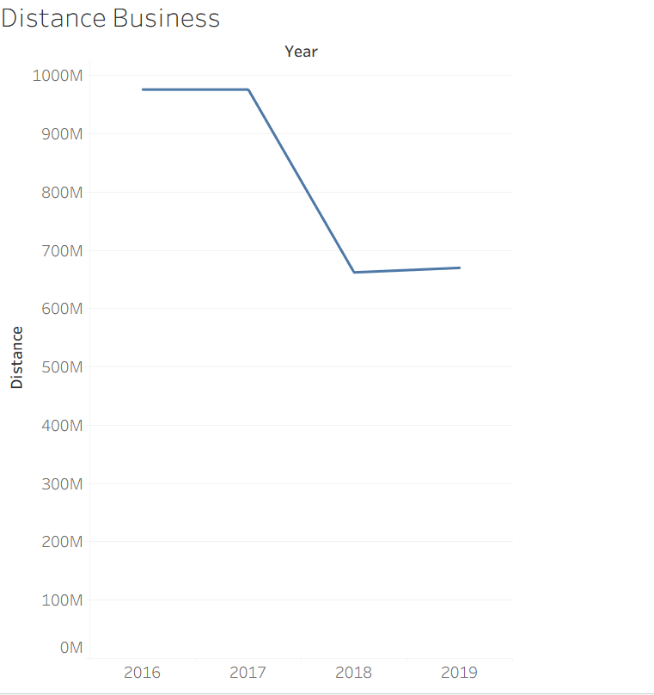

Task 3b: Evaluate the outcomes and effectiveness of the second company initiative, which aimed to reduce employee commuting (Category 7) emissions. Support your evaluation with 1 to 3 data visualizations created in Tableau.

The company 2 did a great job at reducing the emissions from 2016 to 2019 as shown by the first visualization below. The company worked on reducing the three types of emissions during 2018, but they were stagnant in 2019.
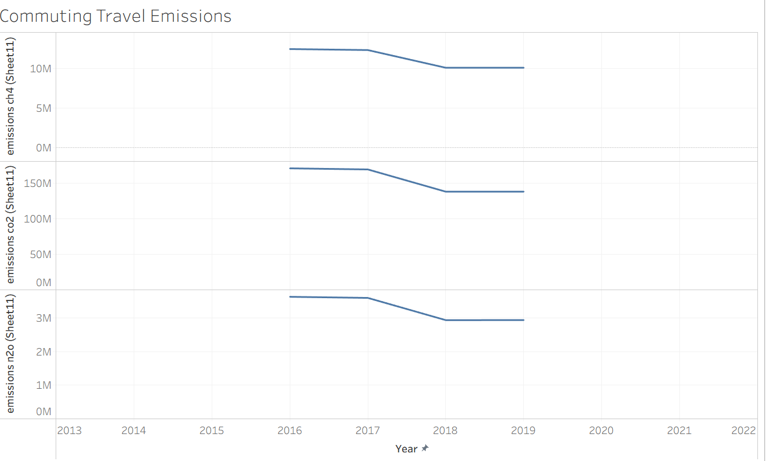
The company worked on reducing the emissions by significantly reducing the emissions resulted by the sales team from 2016 to 2019. (129k to 79k emissions). The company reached a great result by encouraging more commutes using bus and transit rails and reducing commutes used by private car over the 3 years as shown by the visualization. The use of public transportation will lead to significant decrease in emissions.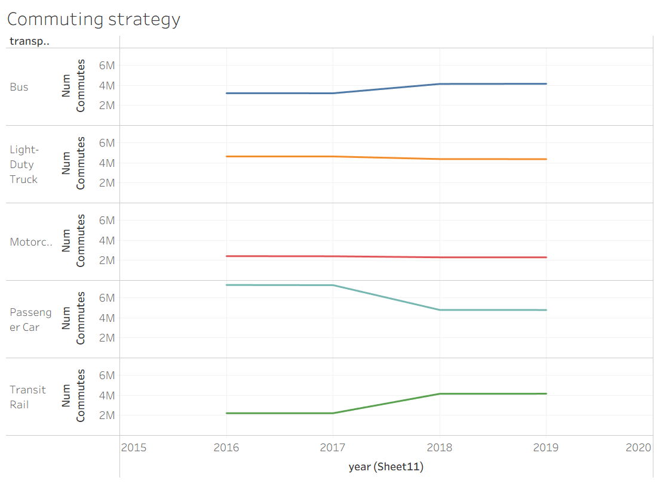
I also noticed that the sales team was responsible for the highest number of emissions was the sales team. However, over the years they managed to significantly reduce their emissions rates. It might be because they are starting to do remote work more often or they are using public transport the most.
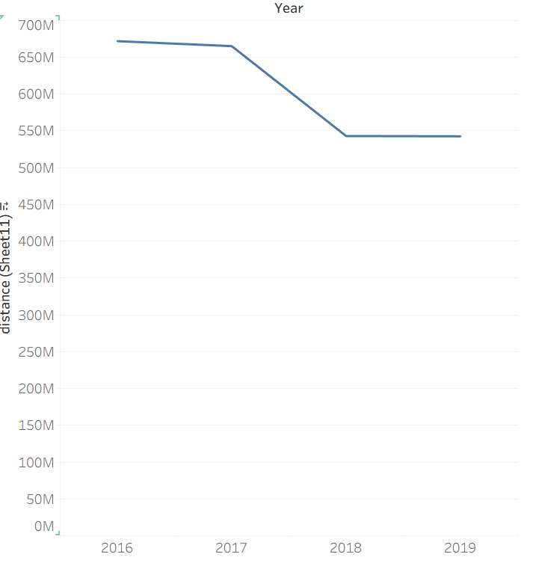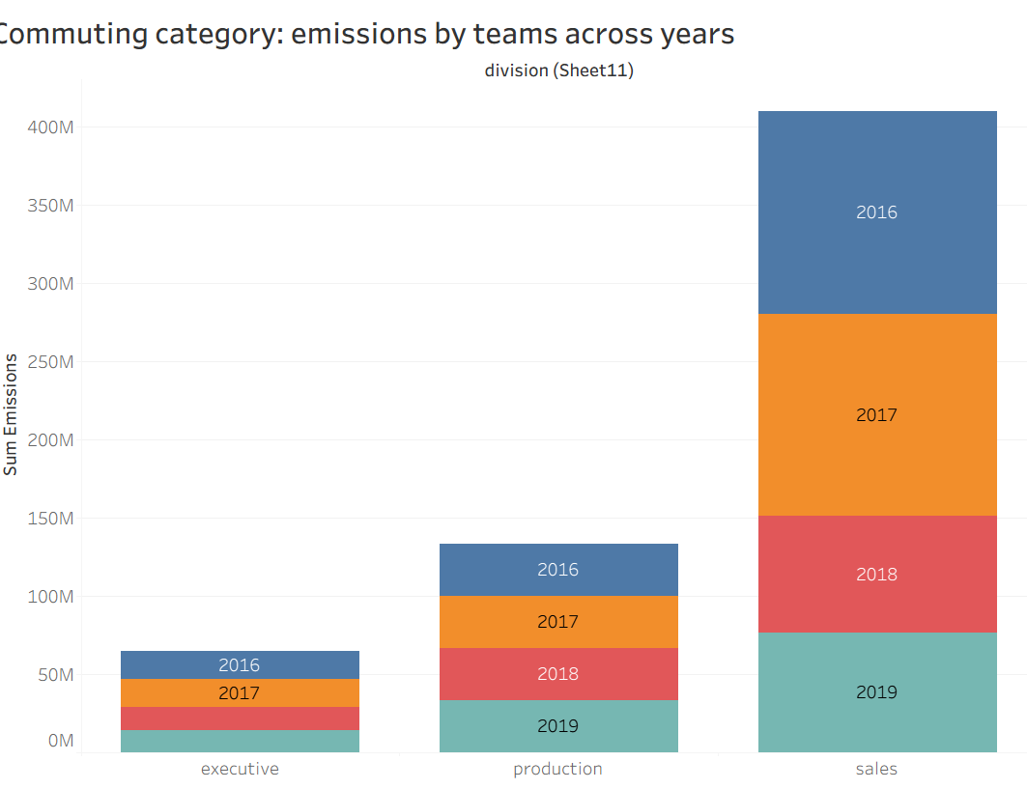

Part 4: Executive Summary
Provide an executive summary that presents your primary findings and overall conclusions. Focus on the most important insights regarding the company’s Category 6 (Business Travel) and Category 7 (Employee Commuting) emissions, as well as the observed impact of the initiatives introduced. Including data visualizations in this section is optional and left to your discretion. to you.
For the Category 6 (Business Travel), the company did so well in significantly reducing the emissions numbers. This is because the company worked on reducing the number of trips for the sales and production division from 2016 to 2019. This is also explained by the reduction of distance of trips in the date across the 4 years. The decrease in use of all means of transportation coupled with the decrease in trips and emissions suggests that the company adopted other solutions such as remote work and teleconferencing to fulfill their tasks without having to travel as much.

For Category 7 (Employee Commuting), the company did well in reducing the overall emissions as well. The most prominent reason behind this change is the decrease in use of private means of transportation like cars and using more public transportation like buses and transit rails. This has a great impact on reducing the total emissions. There is also a significant decrease in emissions cause by the sales team, which may be due to new company policies that imposed restrictions on that team.

